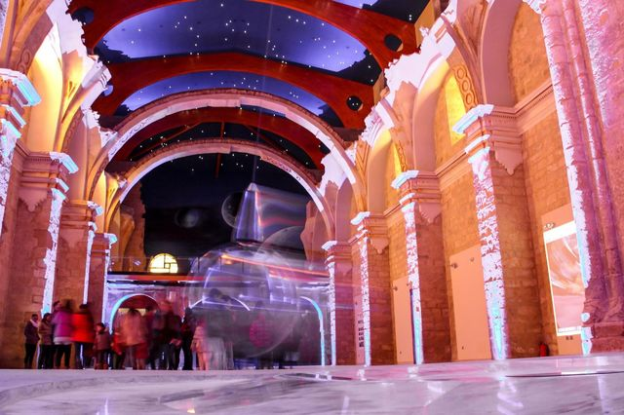
Application Pack

Fundación STARLIGHT – fundacionstarlight@fundacionstarlight.org
C/ Vía Láctea s/n 38205 La Laguna – Tenerife. Tfno.: (34) 922 315 140.
fundacionstarlight.org

STARLIGHT CULTURAL CENTER
(Starlight Astronomic Monument)
Contents
1. The Starlight Foundation
2. Introduction
3. Pre-registration Form

- The Starlight Foundation

One of the purposes of the Starlight Foundation (FS) is to spread the initiative intended to preserve the night sky regarding it as a valuable heritage of our own, in such a manner that mechanisms and actions can be developed for the enjoyment of this asset and to value it as an important scientific, cultural, environmental and tourist resource.
The FS spreads and promotes local, national and international initiatives which favor the protection of this common heritage which is the starred sky and its great scientific, cultural, environmental and tourist value.
The FS considers the “tourism of the stars” a valuable tool in order to safeguard the custody of the clean skies from all pollution and not only for landscape reasons, of culture and leisure but also as a protection measure for the many species which need the dark sky for their survival.
The FS adds to its accreditations the modality of Starlight Cultural Center (Starlight Astronomic Monument) to this movement towards the “Tourism of the stars”, thus widening a manner of making the society aware of astronomy in singular places which combine traditional and scientific culture.

On one hand, the Foundation intends, through its WEB, to publish the places certified as Starlight Cultural Center (Starlight Astronomic Monument), being aware that by doing so it is promoting the assistance of visitors to these singular places approaching them to the scientific culture linked to the knowledge of the Universe.

With this aim, the Foundation will keep a regular information in all the Starlight network about the astronomic events which have happened along the year and will provide materials which may be useful.

On the other hand, the Foundation can provide basic training, if required, to the human team which is going to be in direct contact with the public, with the aim of complying strictly with the activities of teaching astronomy in such Center, as well as training for the use of the observation tools which may be used.

- Introduction

The Starlight Foundation appreciates your interest in being certified as Starlight Cultural Center (Starlight Astronomic Monument) ®.

The requester of this Certificate can be the owner, public or private, or its legal representative.
According to the procedure established in order to perform this Certification, the first step is to fulfill this form in which the following points must be evidenced with documents:

- The requester has the legal capacity to represent the location likely to become Starlight Cultural Center (Starlight Astronomic Monument).
- The requester or the institution it represents adheres formally to the “Starlight Statement of La Palma” and states its intention of complying and promoting the general sustainability principles. *
- The requester meets strictly the conditions described in the procedure of the System of Starlight Certification and Accreditations for Starlight Cultural Centers (Starlight Astronomic Monuments)
* The “Statement of La Palma” and the membership model are attached.

- Pre-registration Form
Information required *:
* All the information provided in this form is of exclusive use of the Foundation and of the auditors who, where appropriate, may perform the auditing in view of the certification. The auditors, on their part, make a commitment towards confidentiality which affects all the documentation they may know due to their job. In addition, in the use of all these data, the Foundation submits at every moment to the provisions established in the Organic Law 15/1999, 13 December, of Personal Data Protection (LOPD), to the Royal Decree 1720/2007 which develops it, and remaining associated current legislation.

AREA AND CONTACT DETAILS
1.
Name of the place
Address
E-mail
Telephone/fax
Web of the lodging
CIF/NIF

2. Name of the individual or legal person applying
Name
Address
E-mail
NIF/CIF
Telephone/fax

3. Director/Manager
Name
Position
E-mail
Telephone/fax

4. Person of Contact
Name
Position
E-mail
Telephone/ fax

TYPE OF CULTURAL MONUMENT
5. Public or private
6. Geographic location (AC/Municipality)
(Coordinates UTM and/or longitudes/latitudes
of the lodging within the area)
7. Use of the area
8. General description
Describe briefly

Location/Environment
Country estate and Building
General resources/
Services and activities

Other
9. m² plot

10. m² built
11. Belonging to other organizations, associations, networks or professional bodies if any.

CHARACTERISTICS OF THE SKY, TOURISM AND ASTRONOMY
12. If the suggested area is located within a Starlight Tourist Destination or Reserve.

Name
General geographic position
Country, region

Location and limits
13. Description of the quality of the sky

Provide all qualitative and quantitative data about the quality of the sky, which the requester has available, after using the systems of measure suggested from the Starlight Foundation. Photographs of the sky can be attached as well which complement these data.

General description

Cloudiness/Clear skies
Darkness
Transparency
Clearness

Current use of the place

Measures of protection of the sky

14. Names and location (geographic coordinates) of the main cities, tourist centers and other potential sources of lighting pollution:

Within a 20km perimeter
Within a 50km perimeter
15. Activities performed currently in the area.
16. Activities which could be performed in the future, as a result of being certificate with the seal Starlight.

17. Current resources and facilities for the observation of the stars

18. We are interested in receiving basic training on astronomy through the courses the Foundation provides to that end to be able to offer and develop activities of quality of star tourism

19. We are able to contribute proactively in the future creation of a Starlight
Destination in the area where our Cultural Monument is located

YES
Describe
NO
Describe
20. In addition to the information mentioned, we can contribute to the Starlight Initiative in the following ways:

Describe briefly

CONTRIBUTION TO THE STARLIGHT INITIATIVE
21. We believe that the involvement in the Starlight Initiative can benefit ourselves in the following manner:

Describe briefly

22. If our establishment decides to continue with the Starlight Certification and to obtain the condition of Starlight Cultural Center (Starlight Astronomic Monument), we would like to be included in the Network of the FS and to be mentioned in the activities of the Foundation and the communications such as:

Describe
(maximum 100 words)
Name and position:

Signature:

Place and date:

We want to receive information about the events and activities of the foundation, information about its certifications, news related to the defense of the night sky and publications of the blog. Likewise, I accept receiving the newsletter of the Foundation. Otherwise indicate NO:

© 2015 STARLIGHT INTELLECTUAL PROPERTY:
This document is property of the STARLIGHT Foundation and it is protected by Intellectual and Industrial Property Rights.

