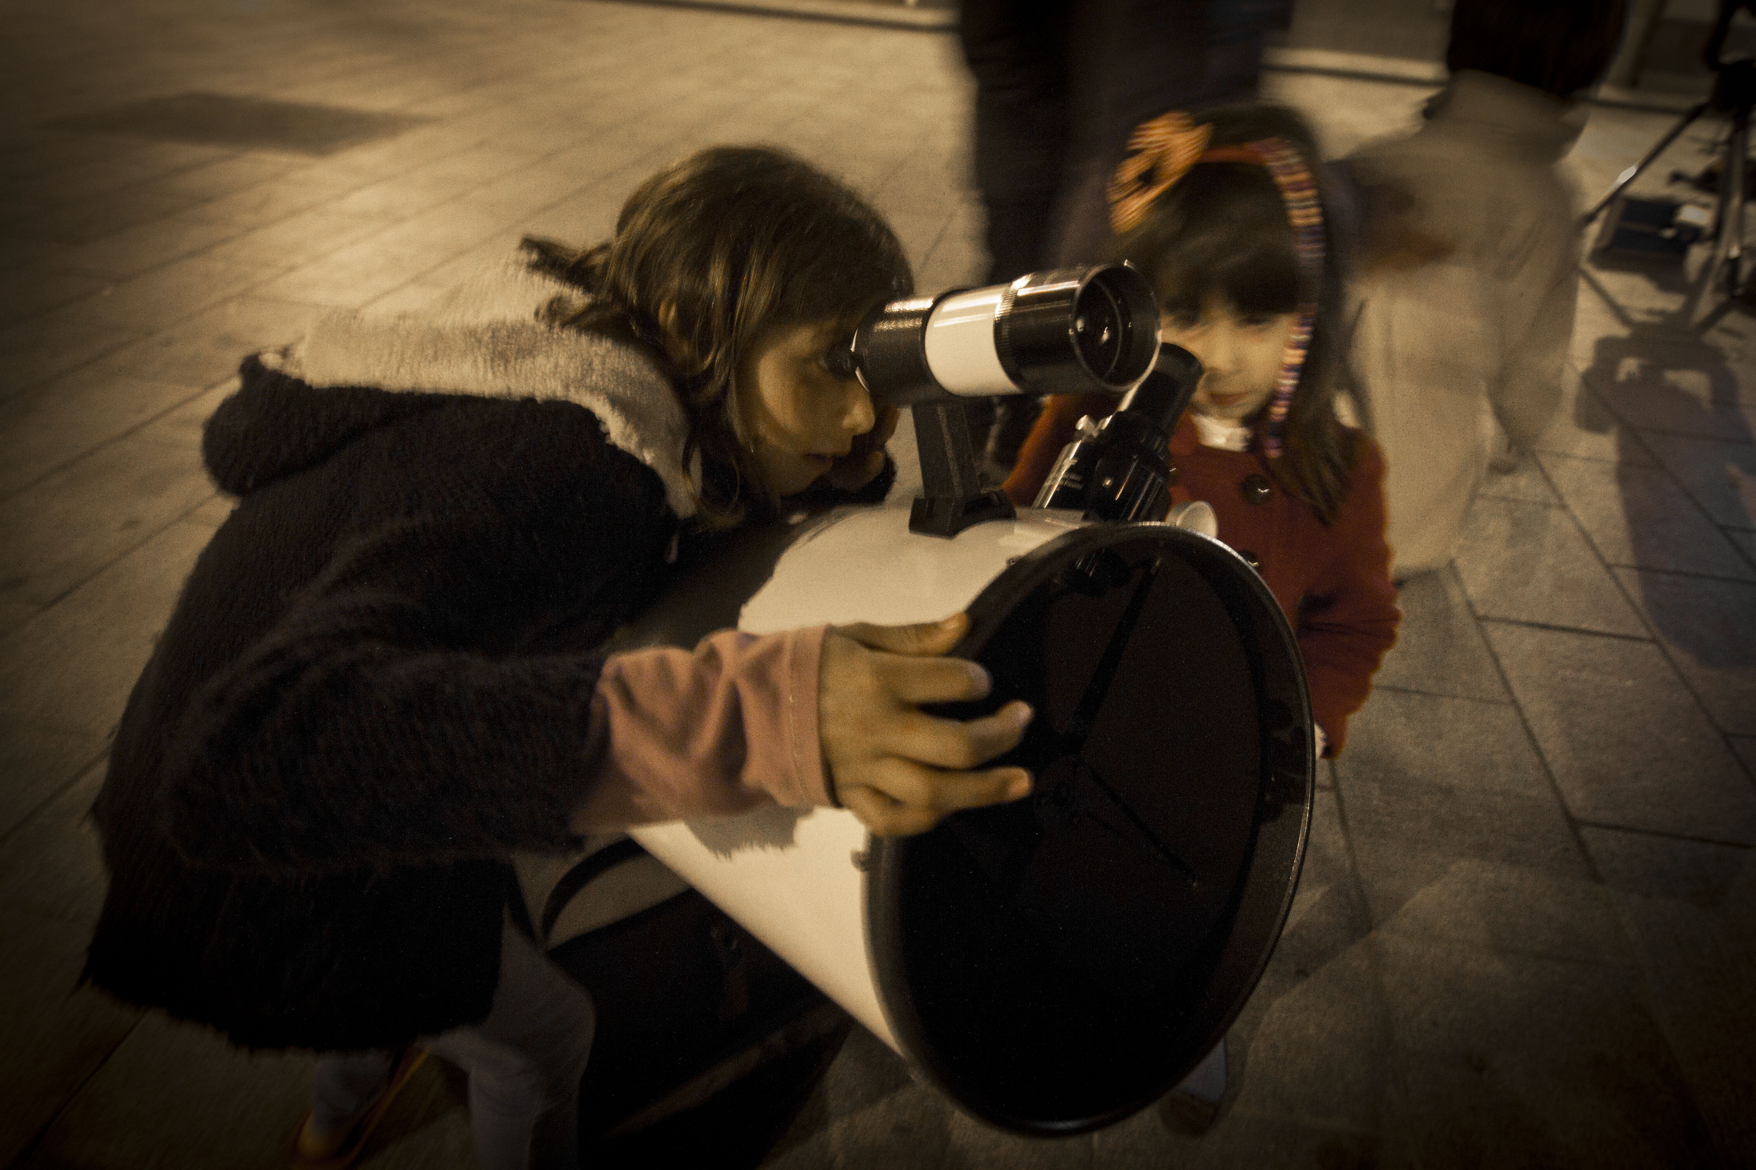

Application Pack
Starlight® Camps

STARLIGHT Foundation – fundacionstarlight@fundacionstarlight.org
C/ Vía Láctea s/n 38205 La Laguna – Tenerife. Telephone: (34) 922 315 140.
fundacionstarlight.org

1. Introduction

The requester of this Certificate can be the legal representative of any entity – administration, body, institution, partnership, company, consortium...-, public or private, with capacities on the management of the candidate camp in order to obtain the Starlight certification and with responsibility on the offer of information and the activities of astronomic, informational, touristic and/or cultural nature developed in the same.
According to the Procedure established in order to perform the Certification, the first step is to fulfill the form attached (Application Pack), in which the following points must be evidenced with documents:
- The requester has the legal capacity to represent the camp likely to be Starlight Camp.
- The requester or the institution it represents adheres formally to the “Starlight Statement of La Palma” and states its intention of fulfilling and promoting the general sustainability principles mentioned in this document.
- The requester fulfills strictly with the conditions described in the procedure of the System of Starlight Certification for Starlight Camps.

2. Application Pack

LODGING AND CONTACT DETAILS
1. Name of the camp

2. Name of relevant natural or legal person
Name

Address
E-mail
Telephone/fax
Web
CIF/NIF

Name
Address
E-mail
NIF/CIF
Telephone/fax
3. Manager/Responsible

Name
Position
E-mail
Telephone/fax
4. Usual Contact Person
Name
Position
E-mail
Telephone/ fax

TYPE OF CAMP
5. Public/private/mixed

6. Geographic region

Community, province and municipality to which it belongs

7. Capacity of the camp/Ages

8. Brief general description

Describe briefly
Location/ Environment
(Coordinates UTM and/or longitudes/latitudes)

Country estate and Building

Resources

Services and activities

9. M² plot

10. M² built
11. Belonging to organizations, associations, networks or professional bodies.

12. Associations, alliances, consortium, etc., with other agents.

Specify

CHARACTERISTICS OF THE SKY, TOURISM AND ASTRONOMY
13. If the camp suggested is located within a Tourist Destination or Starlight Reserve.

Name
General geographic position
Country, region…

Location and limits (coordinates UTM and/or longitudes/latitudes) of the lodgment within the certified area

14. Description of the quality of the sky and reasons why it is deemed that it gathers the necessary characteristics for the development of star tourism and didactic activities.
(Provide all qualitative and quantitative data about the quality of the sky, which the requester has available, after using the measure systems suggested by the Starlight Foundation. Photographs of the sky may be attached as well which complement these data.)
General description

Darkness (and other parameters of the quality of the sky if available)

Possible places of the environment where observation is possible

Protection measures of the sky

15. Names and location (geographic coordinates) of the main cities, tourist centers and other likely sources of lighting pollution.

Within a 3km perimeter
Within a 5km perimeter
16. Current and future activities of astronomic, scientific, cultural or educational tourism which offers the camp in order to be offered as Starlight Camp.

17. Other activities related to the tourism of the stars (if any) which are performed currently in its action area by other entities.

18. New activities which could be performed due to being accredited as “Starlight Camp”

19. Resource and facilities of the camp for the observation and didactic of the stars.

TRAINING AND SPECIALIZATION
20. We are interested in receiving information through the courses of astronomic monitors which the Foundation provides to this end in order to develop activities of interpretation of the sky and to correctly teach the use of observation equipments and other instrumental resources of the camp.

YES/
Describe
NO/
Describe
21. We have the will of telling/hiring, if needed, specialized staff (Guides or Starlight Monitors) in the activities of Tourism of the Stars which we provide in our camp.

Describe

CONTRIBUTION TO THE STARLIGHT INITIATIVE
22. We can contribute proactively with the future creation of a Starlight Destination in the geographic area where our Camp is located.

Yes/ Describe

No/ Describe

23. In addition to the previous information mentioned, we can help the Starlight Foundation in the following ways...

Describe

24. We think that the involvement in Starlight can benefit our organization in the following manner:

Describe

25. If our camp decides to continue with the Starlight Certification and to obtain the condition of Starlight Camp, we would like to be included in the Network of Starlight Camps and to be mentioned in the activities of the Starlight Foundation and its communications as...

(Describe with a maximum of 100 words)

Once the Application Pack has been received, together with the payment of pre-registration, with the data about the quality of the sky and tourist activities, the Foundation will study if the proposal meets the objective conditions for the certification and the requester will be informed about the specific costs of his/fer case and the specific procedure to be followed.
Signed (name and position)

Signature:

Place and date:

I want to receive information about the events and activities of the foundation, information about its certifications, notices related to the defense of the night sky and publications of the blog. Likewise, I accept receiving the newsletter of the Foundation. Otherwise, specify NO:
© 2015 STARLIGHT INTELLECTUAL PROPERTY:
This document is property of the STARLIGHT Foundation and is protected by Intellectual and Industrial Property rights.

All the information provided in this form is of exclusive use for the Foundation and auditors who, where appropriate, perform the audit in view of the certification. The auditors, por their part, sign a confidentiality agreement which affects all the documentation they may know due to their work. In addition, in the use of all these data, the Foundation submits, at every moment, to the provisions established in the Organic Law 15/1999, dated 13 December, on Personal Data Protection (LOPD), to the Royal Decree 1720/2007 which develops it and remaining associated valid legislation.

