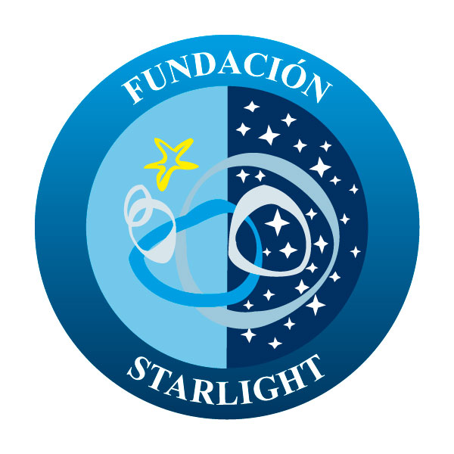

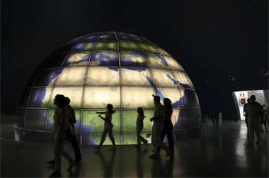

Application Pack
Starlight® Stellar Parks and Stellariums

STARLIGHT Foundation – fundacionstarlight@fundacionstarlight.org
C/ Vía Láctea s/n 38205 La Laguna – Tenerife. Tel.: (34) 922 315 140.
fundacionstarlight.org

- Introduction

The applicant of this Certificate may be the legal representative of any entity – administration, body, institution, association, company, consortium… -, public or private, with powers in the management of the space eligible to receive the Starlight certification to which it refers and with responsibility over the information offer and the activities of an astronomical, tourist and/or cultural nature developed in the proposed Starlight Park and Stellarium.
In accordance with the established Procedure to perform the Certification, the first step is to fill in the form attached (Application Pack), in which proof must be shown through written documents of the following points:
- The applicant has the legal capacity to represent the establishment susceptible of being Starlight Park and Stellarium.
- The applicant or the institution which it represents is formally adhered to the “Starlight Declaration of La Palma” and declares its purpose of accomplishing and promoting the general principles of sustainability.
- The candidate strictly complies with the conditions described in the procedure of the Starlight Certification System for Starlight Stellar Parks and Stellariums.

- Stellar Parks& Stellariums
The Starlight Foundation has created a System of Certification based on the principles contained in the "Declaration on the Defense of the Night Sky and the Right to the Light of the Stars", in whose preparation, in addition to the IAC, participated actively representatives of various organizations, such as UNESCO, the World Organization of Tourism (UNWTO) or the International Astronomical Union (IAU) ,for the protection of night skies as part of our natural resources and, additionally, to promote associated scientific, cultural, and landscape values.
There are several modalities within this system. One of them is “Stellar Parks” and “Stellariums”.
“Stellar Parks” are defined as rural areas -not necessarily large places- generally belonging to municipalities that protect its night sky enough to allow observational, educational, cultural or recreational activities linked to astronomical events (passing comets, eclipses of the sun and moon, planet alignments, meteor showers, etc.).
Usually, amateur astronomers can find facilities for observation in a “Stellar Park”. Since they are close to urban areas, it is necessary to protect them from light pollution, taking advantage of the topography of the location. These actions should be reinforced with specific actions by the municipality or private entities to adapt artificial lighting.
“Stellariums” are a simple, permanent infrastructure installed in areas with a clear, dark sky. They allow leisure activities related to the contemplation of the stars and astronomical observation.
They are “viewpoints open to the sky”, promoted by governments, organizations or private entities to encourage interest in the contemplation of the heavens and astronomical knowledge among the public.
“Stellariums” are intended to facilitate the cultural and educational knowledge of the Universe and provide a basic tool to groups and associations of amateur astronomers for their observations.
These facilities can be located in places with good sky quality (Reserves / Destinations) or locations with a lower quality sky but with good conditions to for observation.
- Application Pack

CONTACT DETAILS
1. Name of the body

2. Competent natural or legal person
Name

Address
E-mail
Telephone/fax
Web
Tax Identification Number

Name
Address
E-mail
Tax Identification Number
Telephone/fax
3. Director/Person in charge
Name
Job
E-mail
Telephone/fax
4. Contact person
Name
Job
E-mail
Telephone/fax

TYPE OF AREA
5. Public/private/mixed

6. Geographic area of the activity

7. Type of area

8. Brief general description

Describe briefly
Location/ Environment
(UTM Coordinates and/or longitudes/latitudes)

Square meter area, dimensions
Resources

Outside lighting system

Service and activities and who perform them

9. Membership of organizations, associations, networks or professional bodies.

10. Associations, alliances, consortiums, etc., with other agents.

Detail
11. Level of satisfaction of the user

CHARACTERISTICS OF THE SKY, TOURISM AND ASTRONOMY
12. If the area proposed is located within a Starlight Tourist Destination or Reserve.

Name
General geographic position
Country, region…

Location and limits (UTM coordinates and/or longitudes/latitudes) of the accommodation within the certified area

13. Description of the sky quality and reasons for which it is deemed that it meets the required characteristics for the development of the astro-tourism or other dissemination activities.
(Provide all the qualitative and quantitative data about the sky quality which the applicant has, after using the measurement systems suggested from the Starlight Foundation. In addition, photographs of the sky may be attached that supplement those data).
13.1. General description

13.2. Darkness
(and other parameters such as transparency, seeing, etc, if measures are available)

13.3. Facilities and outside locations of the environment where we can watch

13.4. Current sky protective measures in the area

14. Names and location (geographic coordinates) of the main cities, tourist resorts and other possible sources of lighting pollution.

Within a 20km perimeter
Within a 50km perimeter

15. Activities of astronomical, scientific, cultural or educational nature which are currently performed in the area of operation of the proposed Park/Stellarium.

16. Other activities currently performed in the proposed area.

17. Other actions offered by the area eligible to be certified as Starlight Park/Stellarium.

18. Actions which could be carried out as a result of the Starlight certification.

19. Available resources and facilities for the observation of the stars and for the teaching of the Universe.

TRAINING AND SPECIALIZATION
20. We have specialized staff for the understanding and teaching of the Universe.

Describe

21. We would be interested in receiving additional specific information through courses taught by the Foundation.

YES/
Describe
NO/
Describe
22. If need be, we are willing to have/hire specialized people (Starlight Guides or Monitors) in the activities that we organize or in future ones.

CONTRIBUTION TO THE STARLIGHT INITIATIVE
23. We are in a position to proactively contribute to the future promotion of a Starlight Destination in the area where our space is located.

Yes/ Describe

No/ Describe

24. In addition to the above, we can collaborate with the purposes of the Starlight Foundation as follows:

Describe

25. We think that the Starlight Foundation can benefit our organization in the following way:

Describe

26. If our area decides to continue with the Starlight Certification and to obtain the status of Starlight Park and Stellarium we would like you to include us in the Network of accredited areas and for us to be mentioned in the promotion actions and in their notices the following way:
(Describe with 100 words or less)

Once the Application Pack has been received with the requested data, and after payment of the pre-registration, the Foundation will study if the proposal meets the objective conditions to proceed with the certification and the applicant will be previously informed about the specific costs of its case and the exact procedure to follow.

Signed
(name and job)

Signature:

Place and date:

I wish to receive information about the events and activities of the foundation, information about its certifications, news related to the defense of the night sky and blog posts. Likewise, I accept to receive the newsletter of the Foundation. Otherwise, indicate NO:

© 2015 STARLIGHT INTELLECTUAL PROPERTY:
This document is the property of the STARLIGHT Foundation and is protected by Intellectual and Industrial Property Rights.

All the information provided in this form is of exclusive use of the Foundation and of the auditors who, as the need arises, perform the audit with a view to the certification. The auditors, on the other hand, undertake a confidentiality commitment which affects all the documentation they may know due to their job. Additionally, in the use of these data, the Foundation will be subjected at all times, to the provisions of the Organic Law 15/1999 of December 13, on personal data protection, to the Royal Decree 1720/2007 that develops it and other legislation in place to be enforced on the subject.

